6.58: The work per unit mass is 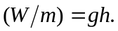
a) The man does work, 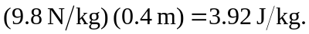
b)
c) The child does work, 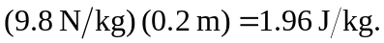
d) If both the man and the child can do work at the rate of 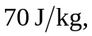 and if the child only needs to use 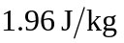 instead of 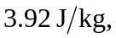 the child should be able to do more pull ups.

